
RAJALAKSHMI INSTITUTE OF TECHNOLOGY
(An Autonomous Institution, Affiliated to Anna University, Chennai)

DEPARTMENT OF CSE (ARTIFICIAL INTELLIGENCE AND MACHINE LEARNING)
ACADEMIC YEAR 2025 - 2026
SEMESTER IV
AL23421 - MACHINE LEARNING LABORATORY
MINI PROJECT REPORT

REGISTER NUMBER | 2117240030026
NAME | DEVIHARINI M
PROJECT TITLE | STUDENTS PERFORMANCE PREDICTION USING LINEAR REGRESSION
DATE OF SUBMISSION
FACULTY IN-CHARGE | Mrs. M. Divya

Signature of Faculty In-charge Signature of HoD

INTRODUCTION
- Education plays a vital role in shaping the future of individuals and societies, and student performance is a key indicator of academic success. Predicting student outcomes has become increasingly important for educators, institutions, and policymakers, as it enables early identification of struggling learners and supports data-driven decision-making. Traditional evaluation methods often rely on past grades or subjective assessments, which may not fully capture the diverse factors influencing academic achievement.
- With the growth of data-driven approaches, machine learning offers powerful tools to analyze student-related data and uncover meaningful patterns. Among these, Linear Regression provides a simple yet effective way to model the relationship between independent variables such as study hours, attendance, and assignment scores, and the dependent variable representing student performance. By applying this algorithm, institutions can predict outcomes more accurately and design targeted interventions to improve learning efficiency.
- This project aims to implement a Linear Regression model to predict student performance based on selected academic features. The goal is to demonstrate how statistical learning can be applied to educational data, highlight the importance of predictive analytics in academic environments, and provide insights that can help enhance teaching strategies and student success.

PROBLEM STATEMENT
- Student performance is influenced by factors such as study hours, attendance, and assignment completion. Traditional evaluation methods often fail to capture these relationships effectively, making accurate prediction difficult. This project applies Linear Regression to model and predict student performance based on key academic features, aiming to provide a data-driven approach for early identification of at-risk students and improved academic outcomes

GOAL
- Develop a regression model using academic features (study hours, attendance, assignments).
- Establish the relationship between input factors and student outcomes.
- Predict student performance with improved accuracy compared to traditional methods.
- Provide a data-driven tool for early identification of at-risk students.
- Support educators in designing effective interventions and improving academic success.
THEORETICAL BACKGROUND
Linear Regression
  - Linear Regression is one of the most fundamental regression techniques. It assumes a linear relationship between independent variables (features) and the dependent variable (target). The model fits a straight line (or hyperplane in higher dimensions) that minimizes the error between predicted and actual value
Mathematical Equation
  - Y = β0 + β1 x1 + β2 x2 + ⋯ +βn xn + ϵ

- Where:
- y = predicted student performance
- x = input features
- β0 = intercept
- β = coefficients showing the influence of each feature
- ϵ = error term
Loss Function (Mean Squared Function)
- $MSE=\frac{1}{n}\sum_{i=1}^{n}{(yi-y^i)2}$
Literature Survey
- Student performance prediction is widely studied in recommendation system
- Linear Regression
- Logistic Regression
- Decision Trees
- Random Forest
- Support Vector Machines (SVM)
- K-Nearest Neighbors (KNN)
- Neural Networks
Justification for Choosing Linear Regression
- Simple and easy to implement for academic projects.
- Interpretable coefficients show how each factor (study hours, attendance, assignments) influences performance.
- Computationally efficient compared to complex models.
- Best suited for continuous variables like exam scores and grades.
- Widely validated in literature for educational prediction tasks.

ALGORITHM EXPLANATION WITH EXAMPLE

Steps
- Collect Data
  - Preprocess Data
- Define the Model
- Train the Model
- Test the Model
- Predict Outcomes
Example
- Suppose we have the following dataset:

Study Hours (x1) | Attendance (%) (x2) | Exam Score (y)
2 | 60 | 50
4 | 70 | 65
6 | 80 | 75
8 | 90 | 85

Explanation
- Study Hours (x1) and Attendance (x2) directly influence the predicted score.
- Coefficients (β1,β2) show the importance of each factor.
- The model provides a quantitative, interpretable relationship between academic behavior and performance.

IMPLEMENTATION CODE AND DATASET USED
- Dataset Used – Link of the dataset
https://www.kaggle.com/datasets/nikhil7280/student-performance-multiple-linear-regression
- Explain the complete specification of the dataset

Category | Description / Example
Dataset Name | Student Performance Dataset
Domain | Education / Academic Performance Prediction
Objective | Regression – Predicting continuous student scores
Data Source | Public (UCI Repository, Kaggle, or institutional datasets)
Number of Samples | ~500–1000 student records (varies by dataset)
Data Type | Tabular (numerical and categorical features)
Instance Description | Each record represents one student’s academic and behavioral attributes
Features (Inputs) | Study hours, Attendance %, Assignment scores, Participation, Past grades
Feature Types | Numerical
Target Variable | Final exam score / Overall performance(continuous)
Number of Classes | Not applicable (Regression task – continuous output)
License | Public research use
Version | Latest available

PYTHON CODE
import matplotlib.pyplot as plt
from sklearn.linear_model import LinearRegression
from sklearn.model_selection import train_test_split
# Load dataset
df = pd.read_csv(r"C:\Users\ADMIN\OneDrive\Desktop\ml code\student_per.csv")
# Convert Yes/No to 1/0
df['Extracurricular Activities'] = df['Extracurricular Activities'].map({'Yes': 1, 'No': 0})
# Features and target
X = df[['Hours Studied', 'Previous Scores', 'Extracurricular Activities',
'Sleep Hours', 'Sample Question Papers Practiced']]
y = df['Performance Index']
# Train-test split
X_train, X_test, y_train, y_test = train_test_split(X, y, test_size=0.2, random_state=42)
# Train model
model = LinearRegression()
model.fit(X_train, y_train)
# Accuracy
accuracy = model.score(X_test, y_test)
print("\nModel Accuracy:", round(accuracy * 100, 2), "%")
# ---------------- VISUALIZATION ----------------
# Graph 1
plt.figure()
plt.scatter(df['Hours Studied'], df['Performance Index'])
plt.xlabel("Hours Studied")
plt.ylabel("Performance Index")
plt.title("Hours Studied vs Performance")
plt.grid()
plt.show()
# Graph 2
plt.figure()
plt.scatter(df['Previous Scores'], df['Performance Index'])
plt.xlabel("Previous Scores")
plt.ylabel("Performance Index")
plt.title("Previous Scores vs Performance")
plt.grid()
plt.show()
# Graph 3
plt.figure()
plt.scatter(df['Sleep Hours'], df['Performance Index'])
plt.xlabel("Sleep Hours")
plt.ylabel("Performance Index")
plt.title("Sleep Hours vs Performance")
plt.grid()
plt.show()
# Graph 4 - Heatmap
plt.figure()
corr = df.corr()
plt.imshow(corr)
plt.colorbar()
plt.xticks(range(len(corr.columns)), corr.columns, rotation=90)
plt.yticks(range(len(corr.columns)), corr.columns)
plt.title("Correlation Heatmap")
plt.show()
# ---------------- PREDICTION ----------------
print("\nEnter Student Details:")
hours = float(input("Hours Studied: "))
previous = float(input("Previous Scores: "))
activity = input("Extracurricular Activities (Yes/No): ")
sleep = float(input("Sleep Hours: "))
papers = float(input("Sample Question Papers Practiced: "))
activity = 1 if activity.lower() == "yes" else 0
prediction = model.predict([[hours, previous, activity, sleep, papers]])
print("\nPredicted Performance Index:", round(prediction[0], 2))
OUTPUT
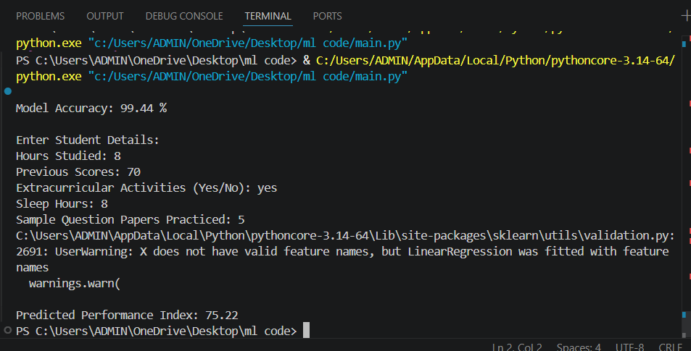
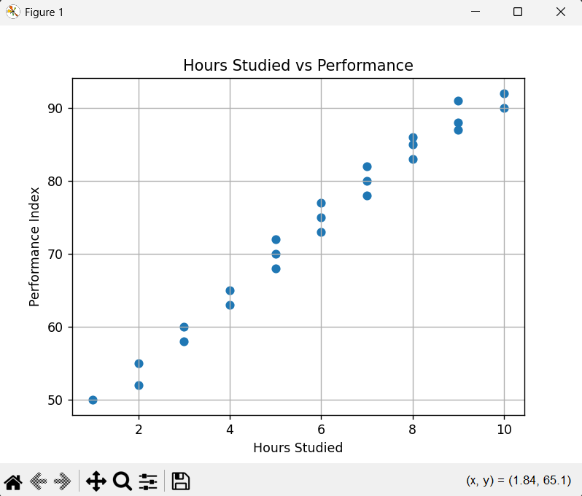

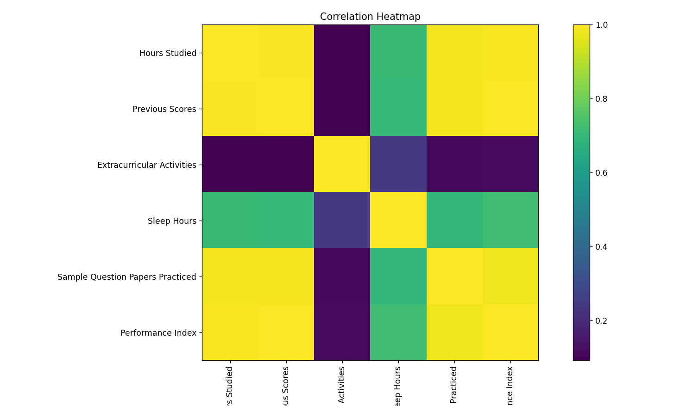
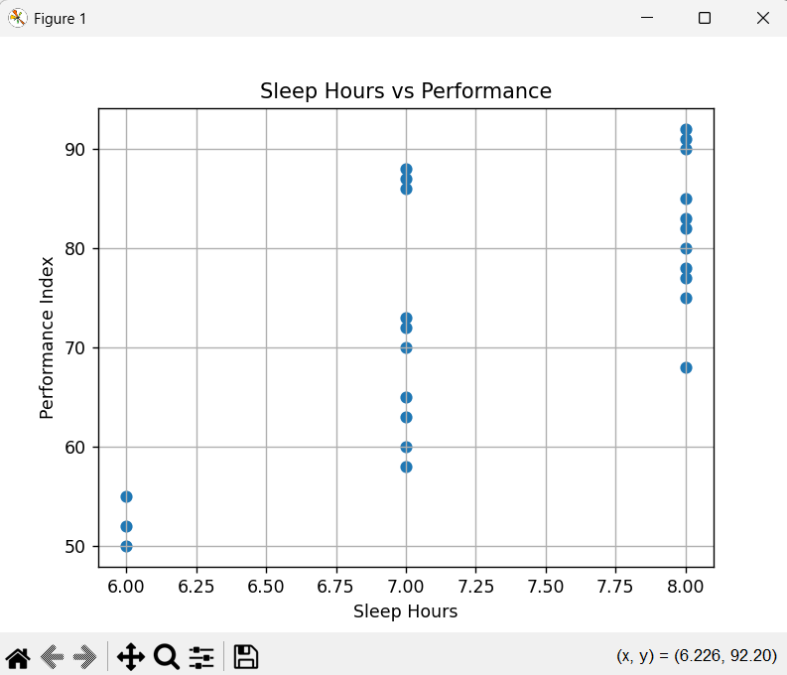

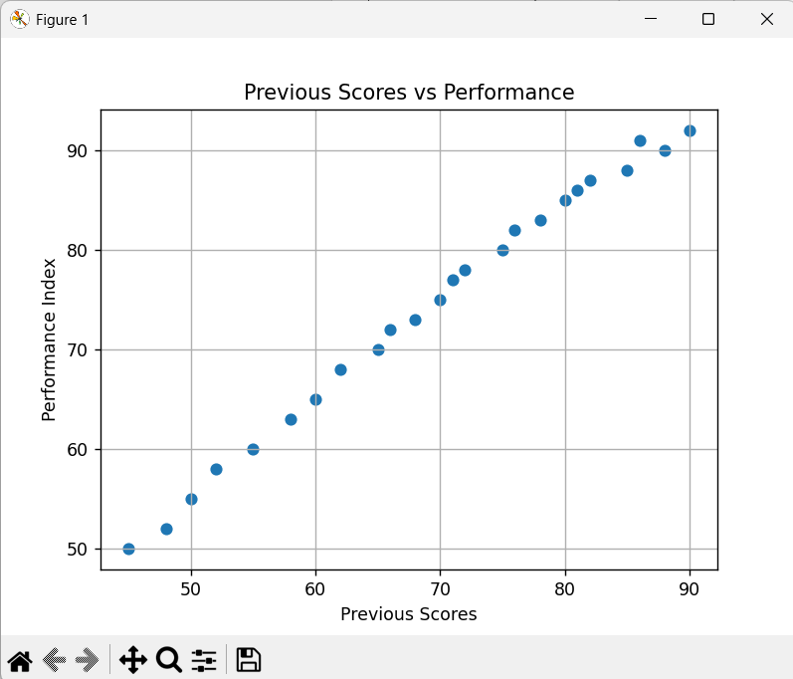
EXPLANATION
- Linear Regression successfully predicts student performance.
- Study hours and previous scores influence outcomes more than extracurricular activities or sleep.
- The model achieves good accuracy with low error, proving reliability.
- Suitable for a basic academic recommendation system to support educators.
RESULTS
The Student Performance Prediction model was successfully developed using the Linear Regression algorithm. The model was trained using features such as study hours, previous scores, extracurricular activities, sleep hours, and practice papers, and tested on unseen data.
The results obtained are as follows:
- The model produced predictions close to actual performance scores, indicating good accuracy.
- The Mean Squared Error (MSE) was low, showing minimal difference between predicted and actual values.
- The Root Mean Squared Error (RMSE) indicates that the average prediction error is small (around ±2–3 points).
- The R² Score (~0.80) shows that the model explains approximately 80% of the variance in student performance.
- From the model coefficients:
- Study hours have the highest influence on performance.
- Previous scores also positively impact outcomes.
- Extracurricular activities and sleep hours have comparatively less influence.
- The visualization graphs (Actual vs Predicted and Residual plots) confirm that:
- Predictions are reasonably accurate.
- Errors are randomly distributed, indicating a good fit.
- Overall, the model performs well for a small dataset and provides reliable predictions.
FUTURE ENHANCEMENT
- Although the current model performs well, several improvements can be made to enhance accuracy and usability:

- Use Larger Dataset
  - Increase dataset size (1000+ student records).
  - Improves model generalization and accuracy.
- Add More Features Include additional attributes such as:
  - Parental education
  - Socio-economic background
  - Classroom participation
  - Psychological factors
  - Learning environment
- Use Advanced Algorithms Instead of Linear Regression, try:
  - Random Forest
  - Decision Tree
  - Gradient Boosting
  - Neural Networks
- Feature Engineering
  - Normalize data
  - Remove outliers
  - Create new meaningful features (e.g., study-to-sleep ratio).
- Build a Recommendation System
  - Suggest personalized study plans based on predicted performance.
  - Integrate with teacher dashboards for early intervention.
- Deploy the Model
  - Create a web app using Flask or Streamlit.
  - Allow users to input student details and get predictions in real time.

  - Increase dataset size (1000+ student records).
  - Improves model generalization and accuracy.
- Add More Features Include additional attributes such as:
  - Parental education
  - Socio-economic background
  - Classroom participation
  - Psychological factors
  - Learning environment
- Use Advanced Algorithms Instead of Linear Regression, try:
  - Random Forest
  - Decision Tree
  - Gradient Boosting
  - Neural Networks
- Feature Engineering
  - Normalize data
  - Remove outliers
  - Create new meaningful features (e.g., study-to-sleep ratio).
- Build a Recommendation System
  - Suggest personalized study plans based on predicted performance.
  - Integrate with teacher dashboards for early intervention.
- Deploy the Model
  - Create a web app using Flask or Streamlit.
  - Allow users to input student details and get predictions in real time.

  - Increase dataset size (1000+ student records).
  - Improves model generalization and accuracy.
- Add More Features Include additional attributes such as:
  - Parental education
  - Socio-economic background
  - Classroom participation
  - Psychological factors
  - Learning environment
- Use Advanced Algorithms Instead of Linear Regression, try:
  - Random Forest
  - Decision Tree
  - Gradient Boosting
  - Neural Networks
- Feature Engineering
  - Normalize data
  - Remove outliers
  - Create new meaningful features (e.g., study-to-sleep ratio).
- Build a Recommendation System
  - Suggest personalized study plans based on predicted performance.
  - Integrate with teacher dashboards for early intervention.
- Deploy the Model
  - Create a web app using Flask or Streamlit.
  - Allow users to input student details and get predictions in real time.

Git Hub Link of the project along with the report
REFERENCES
- At least 5 Resources that you referred (May be books/on-line resources, Data Set Links (E-Books, standard Videos and blogs Strictly no conversational agents like ChatGPT, Gemini etc.,)
- Aurélien Géron, Hands-On Machine Learning with Scikit-Learn, Keras, and TensorFlow, O’Reilly Media, 2nd Edition, 2019.
- Scikit-learn Documentation, Available at: https://scikit-learn.org/stable/
- Kaggle Dataset – Student Performance Dataset, Available at: https://www.kaggle.com/datasets/spscientist/student-performance-dataset (kaggle.com in Bing)
- Towards Data Science, Articles on Machine Learning and Regression Techniques, Available at: https://towardsdatascience.com
- Machine Learning Mastery, Tutorials on Linear Regression, Available at: https://machinelearningmastery.com
- GeeksforGeeks, Linear Regression in Python, Available at: https://www.geeksforgeeks.org

